Smart band app design

Quantified student

Jasper van den Meiracker - 07/04/2022

Contents

**Version** **3**

**Introduction** **4**

**Needs** **5**

The client 5

The user 5

Technical requirements 5

**Alternative smart band apps** **6**

Wear OS 6

Galaxy wearable & Galaxy fit 6

Huawei Health 6

Apple Watch & Apple health 6

**Conclusion** **7**

**Reflection** **8**

# **Version**

| **Version** | **Date** | **Author** | **Change** | **Reviewed by** |
| --- | --- | --- | --- | --- |
| 1.0 | 04/04/2022 | Jasper | Initial Draft | Neal Geilen |
| 1.1 | 05/04/2022 | Jasper | Submission of first version | Eric Slaats |
| 2.0 | 05/04/2022 | Jasper | Added reflection |  |
| 2.1 | 07/04/2022 | Jasper | Rewritten the document |  |

# **Introduction**

Quantified Student (QS) is a project in which the focus is on improving student performance. To support this goal we want to use a smartwatch to track data of the student called the QS Smartwatch. In order to create the application for the QS Smartwatch we need to have a list of requirements and knowledge about existing applications with a likewise purpose. In this document, we will create this list of requirements for the application for the smartwatch and analysis on the other available applications.

# **Needs**

## The client

The client wants an application that collects all the data from the smartwatch and saves this data to create relations between events in Canvas and the data from the smartwatch

## The user

The user wants to easily connect a new smartwatch to the phone/app. Also, the client wants to see their collected health data in relevant overviews.

## Technical requirements

| # | Priority | Description |
| --- | --- | --- |
| N-1 | Must | Data is collected from the smartwatch and sent to the QS dashboard API. |
| N-2 | Must | Users can connect their smartwatch to their phone with the app. |
| N-3 | Must | The application is easy to use and uncluttered. |
| N-4 | Should | The application can send the data from any watch to the QS dashboard API. |
| N-5 | Could | A dashboard where the user can see heart rate, stress, SPO2, sleep and steps in an overview based on time history. |

# **Alternative smart band apps**

The applications sole cause according to the musts is to make it possible to connect to your watch and send data to the API. If we were to look at the UI of comparable applications you will want to look at only the pairing process and the connected devices. Some good examples would be WearOS, Galaxy wearable and Apple watch. 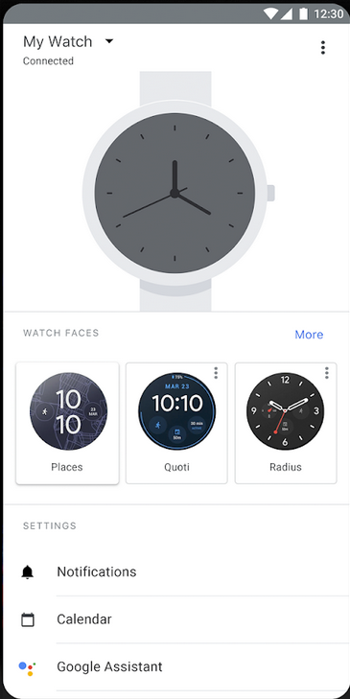

## Wear OS

Is the management app for wearables that use Wear OS, formerly named Android wear and created by Google. The Wear OS app is used to manage the connection between the smart band and the phone. It has no feature to read out the sensors for health purposes, which is a “could” for our application. On the other hand, you are able to look at this data on the watch itself. This application gives the possibility to change the face of the watch and adjust a bunch of settings for the watch. Since we only need a pairing process and some basic information about the connected watch, this application is not a very relevant reference for our app.

## 

## Galaxy wearable

Is the management app for wearables created by Samsung. The Galaxy Wearable app is used to manage the connection between the smart band and the phone. It has no feature to read out the sensors for health purposes. However, you can add the Galaxy Fit app to read out the health-related data, but it is not implemented in the Galaxy Wearable application. As you see in the image you can manage the look of your watch. However a more important feature which would be nice for our application is the ability to see the watch battery and the RAM and storage of the watch.

## 

## 

## 

## Apple Watch

The application for the apple watch is somewhat comparable to the application of the WearOS. The app is used to manage the connection between the watch and the phone. The app also gives the possibility to change the face of the watch, but does not show any relevant information about the watch like the battery life. Since our application is solely focused on the connection this app is not a great reference for our app.

# **Alternative smart band apps regarding health**

It would be nice to have an interface for all the health related data from the watch, but this is not a must for our application. If we were to implement this feature the following applications could be a reference.

## 

## Huawei Health

Is the management app for wearables created by Huawei. The Huawei Health app has a lot of features that would be good for the feature within our application as well. You start on a dashboard with all the relevant information about your health. You can see your steps, minutes walked, heart rate and time asleep. The dashboard displays all the data that we want to display in a history-based manner. For these reasons, the user interface of this application is a very relevant example for this feature of the application.

## Galaxy fit

The interface of the Galaxy Fit app is not very user friendly for our use cases, because we would need a (preferably one page) dashboard that shows all the data that has been collected. Within the galaxy fit app, you need to customize a lot first. Besides that, the application is very cluttered and does not show the health data in an organized manner. If we were to implement this feature this would not be a good reference.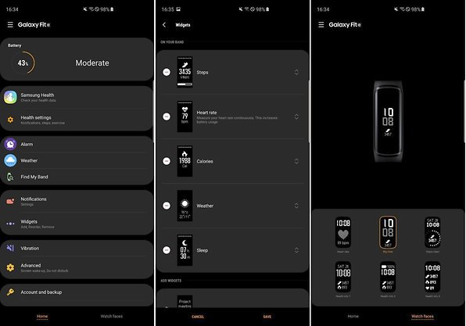

## 

## Apple health

Is the app for the Apple watch. In this dashboard, the data is displayed in a slightly different manner than the other apps. There is a summary and a list of categories. In the summary, you see the two or 3 most important things like heart rate. If you go to the categories you get a list of all the features and once you press a feature you get the data history of this specific feature. This could be useful if we want to make the application useful for different kinds of watches. This way we can just show the health categories based on the protocol and watch that is being used. This is why this application can also be a relevant example for this feature for the application..

# **Conclusion**

When we design the app we have to keep the requirements in mind. We will have to make at least one dashboard within the app but this could become two; One for seeing pairing with the devices and one for all the data that has been retrieved with the watch. The application should gather the following data and send this to the API:

* Heart rate
* Stress
* Oxygen saturation
* Sleep
* Steps

This data can be read from the Huawei Band 6. However, for future use cases, the app should be expandable to support other data. That is why the app should be expandable in a way that it is no hassle to add a different watch than the Huawei Band 6. Since it is most important that there is a clear overview of connected watches we should not focus on one of the existing applications. We should create a simple list of connected watches. However, once connected, the Galaxy Wearable has a nice feature where you see the battery life of the watch and other technical data. This should be kept in mind while creating the app.

For the health feature, we should make an interface where you can add other health categories based on the watch used. Of all the other applications, the way the apple health app is designed is the best way to keep it expendable. Their app shows a list of the categories and once you choose a category you get the data history. The benefit of the Huawei Health app is that the dashboard is less cluttered and you see all data when you open the app. If we were to use these interfaces as inspiration we would have to make a choice between expandability or usability.

If we want to have all categories displayed within one page it is best to create a combination of the Huawei Health app and the Apple Health app. We could make blocks on the frontpage showing basic data per category and once you press the category you get the detailed data from that category.

# **Reflection**

I started this research after talking to the project lead about the requirements for the QS Smartwatch. After this talk I concluded that the main goal of this application would be to display all the data retrieved by the smartwatch within a dashboard on a mobile app. After having a talk with Eric it became clear that the goal of the smartwatch was way different. The smartwatch is being used to retrieve data from the students regarding stress and sleep to get a better understanding of the issues within the learning process.

With this in mind, the frontend of the application of the smartwatch is less relevant, since you can already access the data of the watch on apps like Huawei Health. The main goal of the Smartwatch should be supplying data and using this data alongside Canvas data to improve student performance. The data can also be displayed with canvas as a plugin, meaning the mobile frontend application for the Smartwatch would be less relevant.

We had a meeting about the goals of the QS smartwatch and we concluded that the QS dashboard is the most important goal. The QS smartwatch is merely a tool to supply data to this dashboard. Since the QS smartwatch is solely for data, the UI of the application became less relevant. We should focus on the transfer of data and a good connection between the watch and the app.

What I have learned from this process is that it is important to have a clear view of the goals of the project you are working on. Also, a lot went wrong in the communication. The stakeholder should have been informed more often to make sure we were doing the right thing with the QS smartwatch.